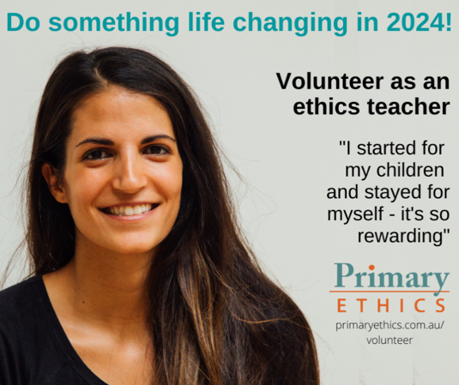

**Do you have half an hour a week? Volunteer as an ethics teacher!**

In ethics lessons, students explore everyday issues suitable for their age. They learn to think and listen carefully, to make decisions backed by good reasons and evidence, to discuss and disagree without putdowns. As an ethics teacher, you’ll get a lot out of it too!

**Our volunteers come from all walks of life**. They can be parents, grandparents, uni students or local community members. You don’t need past teaching experience. Primary Ethics offers full, free training, lesson scripts and ongoing teaching support.

**Curious?**Email [name] on [email] or scan this code to visit [primaryethics.com.au](http://www.primaryethics.com.au/)/volunteer